Xi’an JIAOTONG-LIVERPOOL UNIVERSITY
西 交 利 物 浦 大 学

Year 2
Course Work Submission

Name | Liu(Surname) | Zhiyong(Other Names)
ID Number | 1509264
Programme | CSE105-Assignment3
Module Title | Introduction to Programming in Java
Module Code | CSE105
Assignment Title | CW3: Java programming project
Submission Deadline | 11th December 2016, 6pm
Lecturer Responsible | Chris Trathen

I certify that:
- I have read and understood the University’s definitions of COLLUSION and PLAGIARISM (available in the Student Handbook of Xi’an Jiaotong-Liverpool University).
With reference to these definitions, I certify that:
- I have not colluded with any other student in the preparation and production of this work;
- this document has been written solely by me and in my own words except where I have clearly indicated and acknowledged that I have quoted or used figures from published or unpublished sources (including the web);
- where appropriate, I have provided an honest statement of the contributions made to my work by other people including technical and other support staff.
I understand that unauthorised collusion and the incorporation of material from other works without acknowledgement (plagiarism) are serious disciplinary offences.

Signature …….…………………………………… Date …………………………………………………

For Academic Office use: | Date Received | Days Late | Penalty

System Design:
All classes:
UsedCarSystemStart
Data
CarForSale
CarSold

- UsedCarSystemStart Class:
A class used to start the system and achieve functions.

Attribute:
isQuit(boolen)
inputSelection(int)

Method:
Main()
Read text file.
Print System information.
Let user to input selection.
Achieve functions.
Write text file.

- Data Class:
A class used to transfer information between classes and text file.

Attribute:
No attributes

Method:

inputCar() (static)
Input a new car to system.

sellCar() (static)
Sell a car,move this car from CarForSale Class to CarSold Class.

writeTextFile() (static)
Write the system information into text file.

readTexFile() (static)
Read the system information from text file.

- CarForSale Class

Attribute:
id, private, int
purchasePrice, private, int
dateOfPurchase, private, Date
isOnSale, private, String
ArrayList<CarForSale> listOfCarsForSale --> to store cars for sale

Method:
getID()
To return id.

getPurchasePrice()
To return purchasePrice.

getDateOfPurchase()
To return dateOfPurchase.

setID( int id )
To set the value of id.

setPurchasePrice( int purchasePrice )
To set the value of purchasePrice.

setDateOfPurchase( Date dateOfPurchase)
To set the value of dateOfPurchase.

flatten()
To return the information of car for sale.

addCar() (static)
To add a new car to the system and note the id, purchasePrice, date

displayCarForSale() (static)
To display the information of cars for sale.

bubbleSort( ArrayList<CarForSale> listOfCarForSale ) (static)
To sort the cars for sale by date.

isUnique(int id) (static)
To test the input id if it is unique in the list of cars for sale.

- CarSold Class

Attribute:
id, private, int
purchasePrice, private, int
salePrice, private, int
dateOfPurchase, private, Date
dateOfSale, private, Date
isOnSale, private, String
ArrayList<CarSold> listOfCarSale --> to store cars which have been sold

Method:
setID( int id )
To set the value of id.

setPurchasePrice( int purchasePrice )
To set the value of purchasePrice.

setSalePrice( int salePrice )
To set the value of salePrice.

setDateOfPurchase( Date dateOfPurchase )
To set the value of dateOfPurchase.

setDateOfSale(Date dateOfSale )
To set the value of dateOfSale.

flatten()
To return the information of car sold.

addCarSold() (static)
To add a car into CarSold Class and remove it from CarForSale Class.

displayCarSold() (static)
To display the information of cars sold.

Testing
First, start the system, it will show the main interface as below:

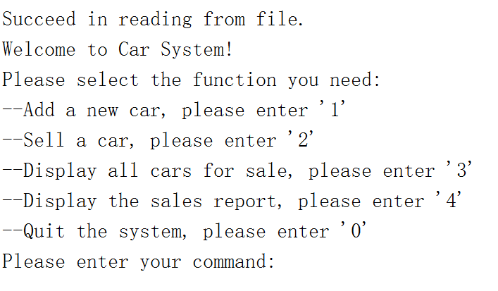
Testing case 1:
There are four functions which user can use, first we can view all the cars for sale, so we input ‘3’.

Results: show a list as below
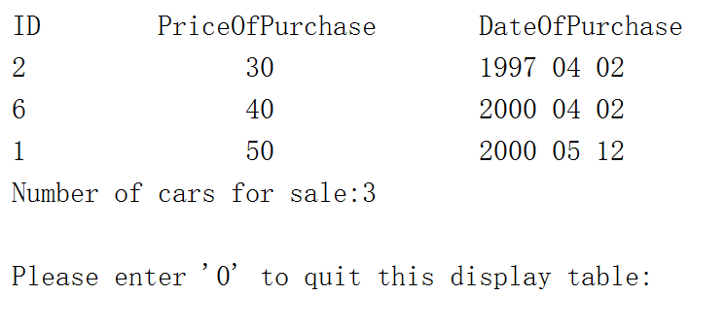
It will show all the cars for sale with their purchase price and purchase date, Besides, the total number of cars for sale is shown at the bottom. If user want to quit this interface, input ‘0’, and the program will return to main interface and wait user to choose other function.

Testing case 2:
If user wants to add a new purchase car into the system, input ’1’.

Results:
If there are 20 cars already for sale, it will show the information as below:

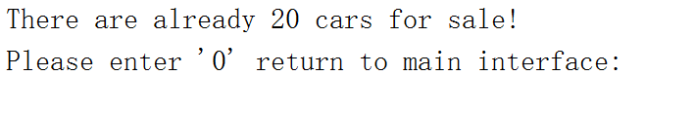
If the number of cars for sale is less than 20, it will let you input id, purchase price, purchase date as below:

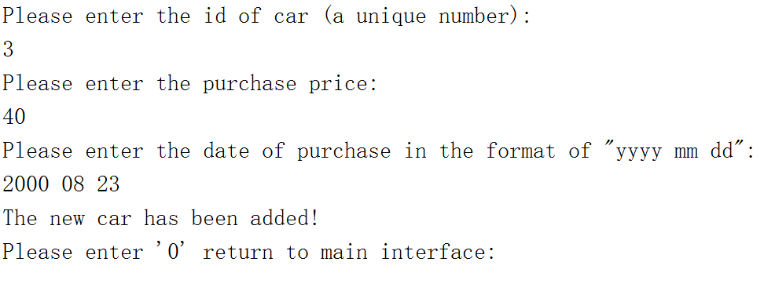
Input ’0’ to return to main interface.

Testing case 3:
If user to choose to sell a car, input ’2’ in the main interface.

Results:
it will show information and ask user to input the id of the car which will be sold, then it will also ask user to input sale price and sale date as below:

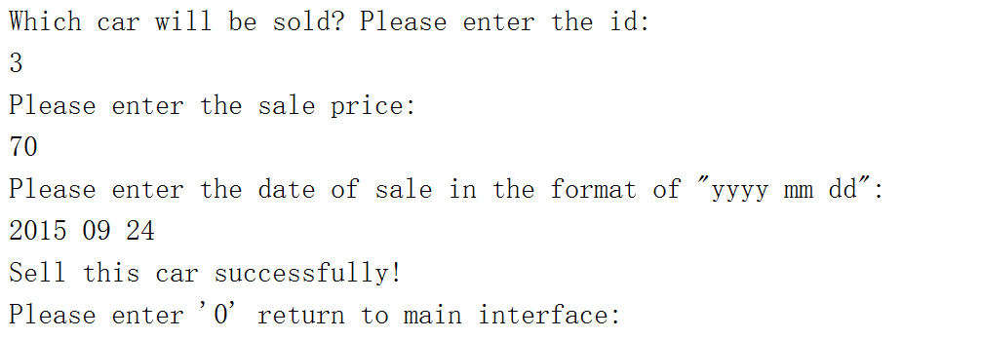

Input ‘0’ to main interface.

Testing case 4:
If user wants to view the sale report, input ’4’ in the main interface.

Results:
It will show the information as below：
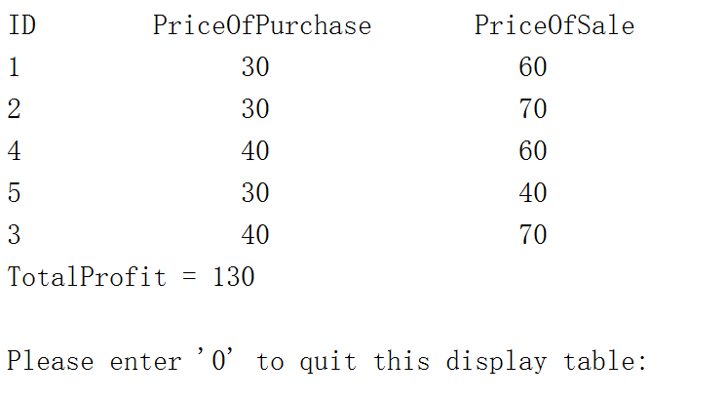

This table shows the id of sold cars with their purchase price and sale price, at the bottom, it shows the total profit.

Input ‘0’ to the main interface.

Testing case 5:
Input ‘0’ in the interface, write information into text and quit the system.

Results:

